**Linux commands**

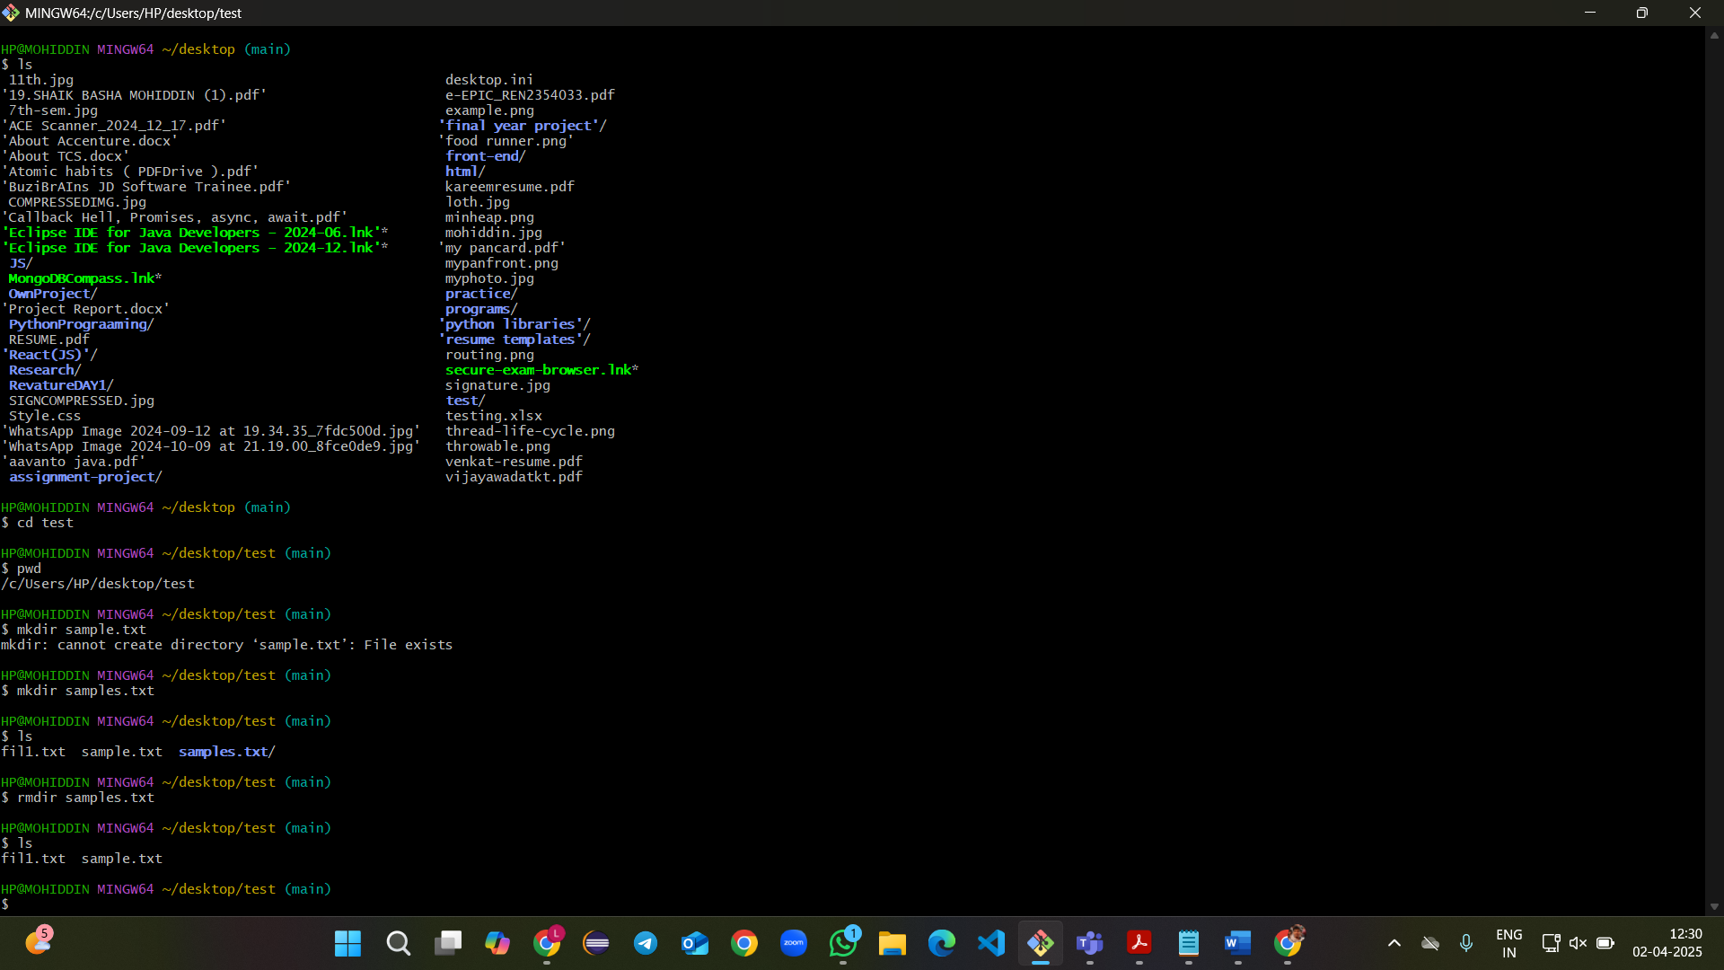

Commands in screenshot-1

Ls -> show list of folders

Cd -> to move forward to directory

Pwd -> show path

Mkdir -> make new directory

Rmdir -> delete directory

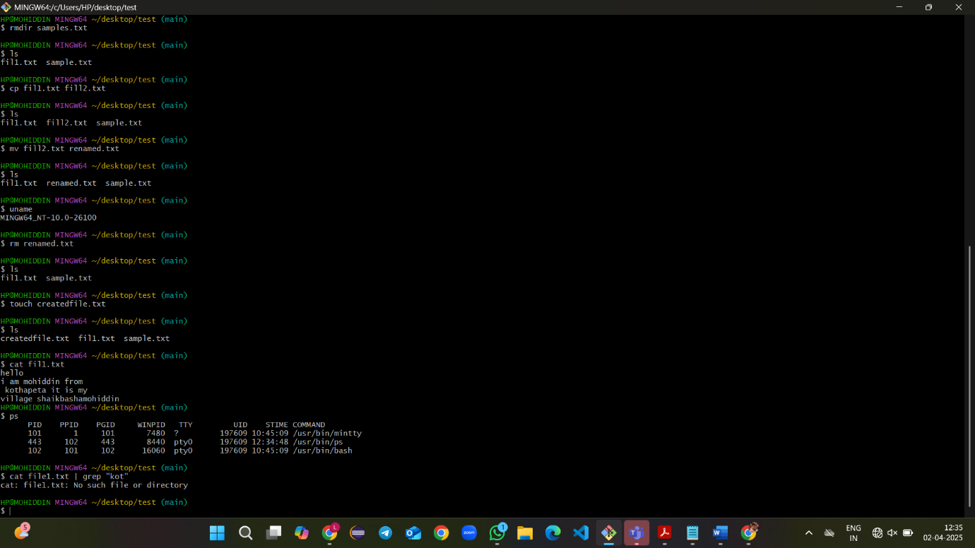

Commands in screenshot-2

Cp -> copy content of one file to another file

Mv -> rename the file

Rm -> remove file

Uname ->show system details

Touch -> create empty file

Cat -> to see content of the file

Ps -> to see active process

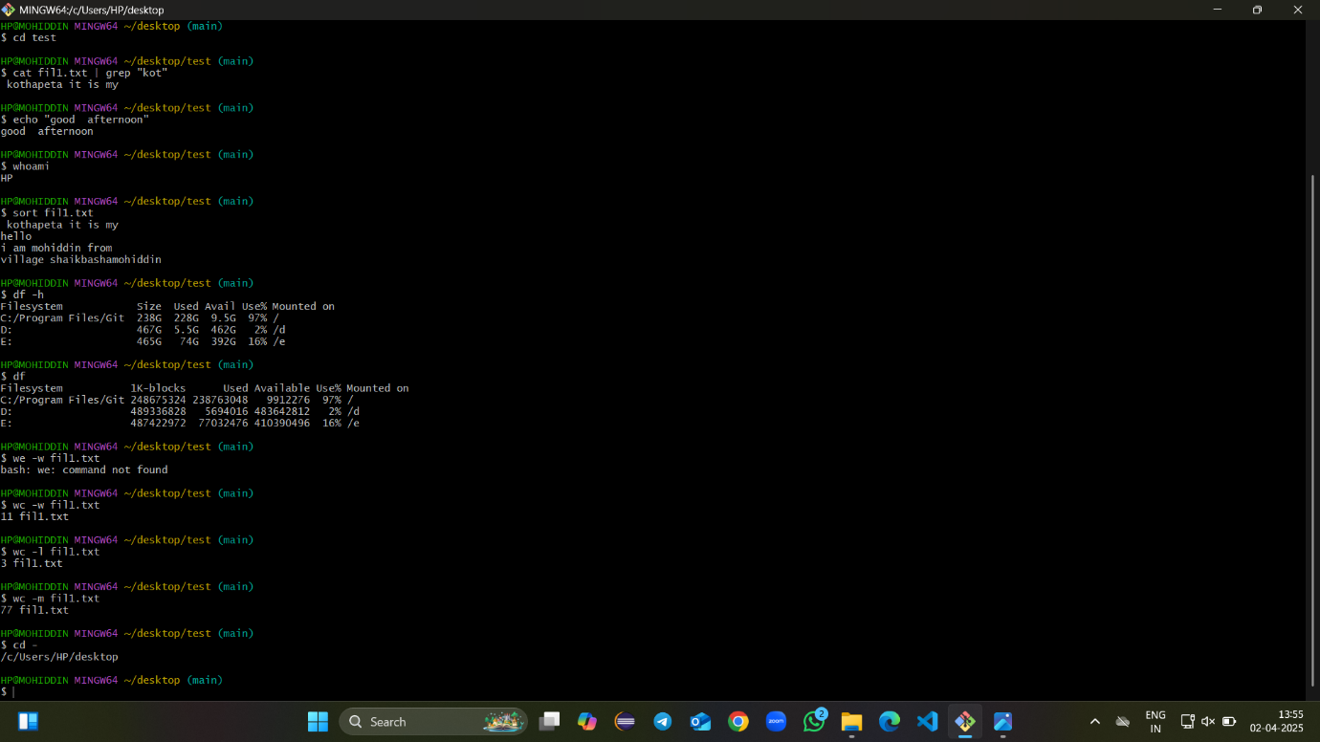

Commands in screenshot-3

Grep -> to get string with the substring you given

Echo -> simply prints the data what you given

Whoami -> to get who is user

Sort -> sort the content in the file

Df -h -> info about storage (detailed)

Df -> similar to df -h but not understandable info

Wc -w -> gives no. of words in file

Wc -l -> gives no.of lines in file

Wc -m -> gives no. of characters in file

Cd - -> to move backward in the directory